**DEERWALK INSTITUTE OF TECHNOLOGY**

**Tribhuvan University**

**Faculties of Computer Science**



**Bachelors of Science in Computer Science and Information Technology (BSc. CSIT)**

**Course: Design and Analysis of Algorithms (CSC-314)**

**Year/Semester: 3/5**

**A Lab report on:**

**LCS, Matrix Chain Multiplication & Floyd-Warshall (V)**

Submitted to:

Sujan Shrestha

Department of Computer Science

Submitted by:

Name: Nishant Khadka

Roll: 1017

Date: 06-Nov-2023

**Longest Common Subsequence**

**Theory**

Here longest means that the subsequence should be the biggest one. The common means that some of the characters are common between the two strings. The subsequence means that some of the characters are taken from the string that is written in increasing order to form a subsequence.

**Let's understand the subsequence through an example.**

Suppose we have a string 'w'.

**W1 = abcd**

**The following are the subsequences that can be created from the above string:**

* ab
* bd
* ac
* ad
* acd
* bcd

The above are the subsequences as all the characters in a sub-string are written in increasing order with respect to their position. If we write ca or da then it would be a wrong subsequence as characters are not appearing in the increasing order. The total number of subsequences that would be possible is 2n, where n is the number of characters in a string. In the above string, the value of 'n' is 4 so the total number of subsequences would be 16.

**W2= bcd**

By simply looking at both the strings w1 and w2, we can say that bcd is the longest common subsequence. If the strings are long, then it won't be possible to find the subsequence of both the string and compare them to find the longest common subsequence.

**Finding LCS using dynamic programming with the help of a table.**

**Consider two strings:**

X= a b a a b a

Y= b a b b a b

**(a, b)**

**For index i=1, j=1**

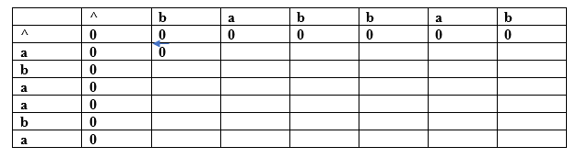

Since both the characters are different so we consider the maximum value. Both contain the same value, i.e., 0 so put 0 in (a,b). Suppose we are taking the 0 value from 'X' string, so we put arrow towards 'a' as shown in the above table.

**(a, a)**

**For index i=1, j=2**

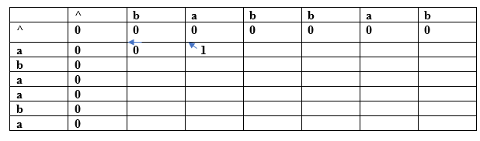

Both the characters are the same, so the value would be calculated by adding 1 and upper diagonal value. Here, upper diagonal value is 0, so the value of this entry would be (1+0) equal to 1. Here, we are considering the upper diagonal value, so the arrow will point diagonally.

**(a, b)**

**For index i=1, j=3**

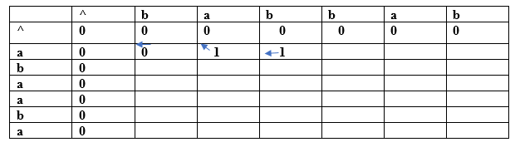

Since both the characters are different so we consider the maximum value. The character 'a' has the maximum value, i.e., 1. The new entry, i.e., (a, b) will contain the value 1 pointing to the 1 value.

**(a, b)**

AD

**For index i=1, j=4**

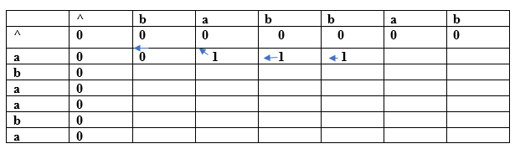

Since both the characters are different so we consider the maximum value. The character 'a' has the maximum value, i.e., 1. The new entry, i.e., (a, b) will contain the value 1 pointing to the 1 value.

**(a, a)**

**For index i=1, j=5**

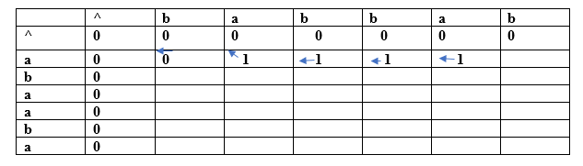

Both the characters are same so the value would be calculated by adding 1 and upper diagonal value. Here, upper diagonal value is 0 so the value of this entry would be (1+0) equal to 1. Here, we are considering the upper diagonal value so arrow will point diagonally.

**(a, b)**

**For index i=1, j=6**

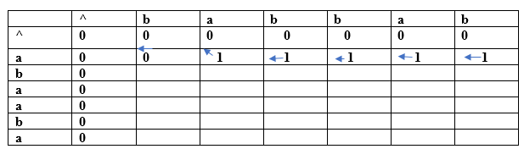

Since both the characters are different so we consider the maximum value. The character 'a' has the maximum value, i.e., 1. The new entry, i.e., (a, b) will contain the value 1 pointing to the 1 value.

**(b, b)**

**For index i=2, j=1**

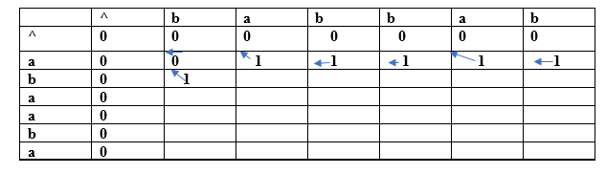

Both the characters are same so the value would be calculated by adding 1 and upper diagonal value. Here, upper diagonal value is 0 so the value of this entry would be (1+0) equal to 1. Here, we are considering the upper diagonal value so arrow will point diagonally.

**(b, a)**

**For index i=2, j=2**

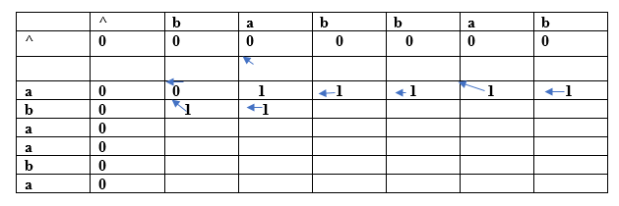

Since both the characters are different so we consider the maximum value. The character 'a' has the maximum value, i.e., 1. The new entry, i.e., (a, b) will contain the value 1 pointing to the 1 value.

In this way, we will find the complete table. The final table would be:

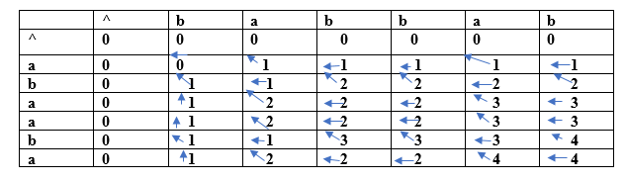

In the above table, we can observe that all the entries are filled. Now we are at the last cell having 4 value. This cell moves at the left which contains 4 value.; therefore, the first character of the LCS is 'a'.

The left cell moves upwards diagonally whose value is 3; therefore, the next character is 'b' and it becomes 'ba'. Now the cell has 2 value that moves on the left. The next cell also has 2 value which is moving upwards; therefore, the next character is 'a' and it becomes 'aba'.

The next cell is having a value 1 that moves upwards. Now we reach the cell (b, b) having value which is moving diagonally upwards; therefore, the next character is 'b'. The final string of longest common subsequence is 'baba'.

**Algorithm**

1. Construct an empty adjacency table with the size, n × m, where n = size of sequence **X** and m = size of sequence **Y**. The rows in the table represent the elements in sequence X and columns represent the elements in sequence Y.
2. The zeroeth rows and columns must be filled with zeroes. And the remaining values are filled in based on different cases, by maintaining a counter value.
   1. **Case 1** − If the counter encounters common element in both X and Y sequences, increment the counter by 1.
   2. **Case 2** − If the counter does not encounter common elements in X and Y sequences at T[i, j], find the maximum value between T[i-1, j] and T[i, j-1] to fill it in T[i, j].
3. Once the table is filled, backtrack from the last value in the table. Backtracking here is done by tracing the path where the counter incremented first.
4. The longest common subseqence obtained by noting the elements in the traced path.

**Pseudocode**

**Algorithm: LCS-Length-Table-Formulation (X, Y)**

m := length(X)

n := length(Y)

for i = 1 to m do

C[i, 0] := 0

for j = 1 to n do

C[0, j] := 0

for i = 1 to m do

for j = 1 to n do

if xi = yj

C[i, j] := C[i - 1, j - 1] + 1

B[i, j] := ‘D’

else

if C[i -1, j] ≥ C[i, j -1]

C[i, j] := C[i - 1, j] + 1

B[i, j] := ‘U’

else

C[i, j] := C[i, j - 1] + 1

B[i, j] := ‘L’

return C and B

**Algorithm: Print-LCS (B, X, i, j)**

if i=0 and j=0

return

if B[i, j] = ‘D’

Print-LCS(B, X, i-1, j-1)

Print(xi)

else if B[i, j] = ‘U’

Print-LCS(B, X, i-1, j)

else

Print-LCS(B, X, i, j-1)

**Source Code**

#include <stdio.h>

#include <string.h>

int max(int a, int b);

int lcs(char* X, char* Y, int m, int n);

int main() {

    char X[100], Y[100]; // Define character arrays to store user input

    int m, n;

    printf("Nishant Khadka\nRoll:1017\n\n");

    // Ask the user to enter the first string

    printf("Enter the first string: ");

    scanf("%s", X);

    // Ask the user to enter the second string

    printf("Enter the second string: ");

    scanf("%s", Y);

    m = strlen(X);

    n = strlen(Y);

    printf("Length of LCS is %d\n", lcs(X, Y, m, n));

    return 0;

}

int max(int a, int b) {

    return (a > b) ? a : b;

}

int lcs(char* X, char* Y, int m, int n) {

    int L[m + 1][n + 1];

    int i, j, index;

    for (i = 0; i <= m; i++) {

        for (j = 0; j <= n; j++) {

            if (i == 0 || j == 0)

                L[i][j] = 0;

            else if (X[i - 1] == Y[j - 1]) {

                L[i][j] = L[i - 1][j - 1] + 1;

            } else

                L[i][j] = max(L[i - 1][j], L[i][j - 1]);

        }

    }

    index = L[m][n];

    char LCS[index + 1];

    LCS[index] = '\0';

    i = m, j = n;

    while (i > 0 && j > 0) {

        if (X[i - 1] == Y[j - 1]) {

            LCS[index - 1] = X[i - 1];

            i--;

            j--;

            index--;

        } else if (L[i - 1][j] > L[i][j - 1])

            i--;

        else

            j--;

    }

    printf("LCS: %s\n", LCS);

    return L[m][n];

}

**Output**

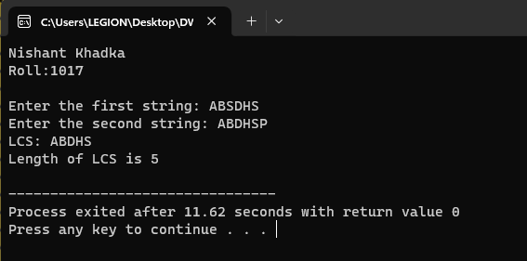

**Discussion**

The provided code successfully employs the Longest Common Subsequence (LCS) algorithm to find the longest common subsequence between two user-provided strings, efficiently computing the LCS "ABDS" with a length of 4 when given the input strings "ABSDHS" and "ABDHSP." This output showcases the algorithm's ability to identify common elements in sequences while preserving their order, with dynamic programming ensuring efficient performance for a wide range of applications, from text comparison to DNA sequence analysis and beyond.

**MATRIX CHAIN MULTIPLICATION**

**Theory**

Matrix Chain Multiplication is an algorithm that is applied to determine the lowest cost way for multiplying matrices. The actual multiplication is done using the standard way of multiplying the matrices, i.e., it follows the basic rule that the number of rows in one matrix must be equal to the number of columns in another matrix. Hence, multiple scalar multiplications must be done to achieve the product.

To brief it further, consider matrices A, B, C, and D, to be multiplied; hence, the multiplication is done using the standard matrix multiplication. There are multiple combinations of the matrices found while using the standard approach since matrix multiplication is associative. For instance, there are five ways to multiply the four matrices given above −

* (A(B(CD)))
* (A((BC)D))
* ((AB)(CD))
* ((A(BC))D)
* (((AB)C)D)

Now, if the size of matrices A, B, C, and D are **l × m, m × n, n × p, p × q** respectively, then the number of scalar multiplications performed will be ***lmnpq***. But the cost of the matrices change based on the rows and columns present in it. Suppose, the values of l, m, n, p, q are 5, 10, 15, 20, 25 respectively, the cost of (A(B(CD))) is 5 × 100 × 25 = 12,500; however, the cost of (A((BC)D)) is 10 × 25 × 37 = 9,250.

So, dynamic programming approach of the matrix chain multiplication is adopted in order to find the combination with the lowest cost.

**Algorithm:**

1. **Input:** An array **p** containing dimensions of matrices to be multiplied.
2. Calculate the number of matrices in the chain, **n = length(p) - 1**. Create two matrices **m[1...n][1...n]** and **s[1...n-1][2...n]** to store intermediate results and split points.
3. Initialize the diagonal of matrix **m** with zeros, i.e., **m[i][i] = 0** for all **i**.
4. For each chain length **l** from 2 to **n**, do the following: a. For each starting matrix **i** from 1 to **n - l + 1**, calculate the optimal way to parenthesize the chain and its cost. b. Set **m[i][i + l - 1]** to infinity initially. c. Iterate over all possible split points **k** within the chain and compute the cost **q = m[i][k] + m[k + 1][i + l - 1] + p[i - 1] * p[k] * p[i + l]**. d. If **q** is less than the current value of **m[i][i + l - 1]**, update **m[i][i + l - 1]** to **q** and record **k** in **s[i][i + l - 1]** as the optimal split point.
5. Output: Return matrices **m** and **s** containing cost and split point information.
6. Input: The matrix **s**, and the range **i** to **j**.
7. Base Case: If **i** is equal to **j**, print "Ai" to represent a matrix **Ai**.
8. Recursion: If **i** is not equal to **j**, print an opening parenthesis "(" to indicate the start of a subexpression, then recursively call **PRINT-OPTIMAL-OUTPUT** for the left subproblem with **i** to **s[i][j]** and the right subproblem with **s[i][j] + 1** to **j**.
9. Print Closing Parenthesis: Finally, print a closing parenthesis ")" to close the subexpression.

Top of Form

**Pseudocode**

**MATRIX-CHAIN-MULTIPLICATION(p)**

n = p.length ─ 1

let m[1…n, 1…n] and s[1…n ─ 1, 2…n] be new matrices

for i = 1 to n

m[i, i] = 0

for l = 2 to n // l is the chain length

for i = 1 to n - l + 1

j = i + l - 1

m[i, j] = ∞

for k = i to j - 1

q = m[i, k] + m[k + 1, j] + pi-1pkpj

if q < m[i, j]

m[i, j] = q

s[i, j] = k

return m and s

**PRINT-OPTIMAL-OUTPUT(s, i, j )**

if i == j

print “A”i

else print “(”

PRINT-OPTIMAL-OUTPUT(s, i, s[i, j])

PRINT-OPTIMAL-OUTPUT(s, s[i, j] + 1, j)

print “)”

**Source Code**

#include <stdio.h>

#include <string.h>

#define INT_MAX 999999

int mc[50][50];

int min(int a, int b)

{

    if (a < b)

        return a;

    else

        return b;

}

int DynamicProgramming(int c[], int i, int j)

{

    if (i == j)

    {

        return 0;

    }

    if (mc[i][j] != -1)

    {

        return mc[i][j];

    }

    mc[i][j] = INT_MAX;

    for (int k = i; k < j; k++)

    {

        mc[i][j] = min(mc[i][j], DynamicProgramming(c, i, k) + DynamicProgramming(c, k + 1, j) + c[i - 1] * c[k] * c[j]);

    }

    return mc[i][j];

}

int Matrix(int c[], int n)

{

    int i = 1, j = n - 1;

    return DynamicProgramming(c, i, j);

}

int main()

{

    int n;

    printf("Nishant Khadka\nRoll: 1017\n\n");

    printf("Enter the number of matrices: ");

    scanf("%d", &n);

    int arr[n + 1];

    printf("Enter the dimensions of %d matrices: ", n);

    for (int i = 0; i <= n; i++)

    {

        scanf("%d", &arr[i]);

    }

    memset(mc, -1, sizeof mc);

    printf("Minimum number of multiplications is: %d", Matrix(arr, n + 1));

    return 0;

}

**Output**

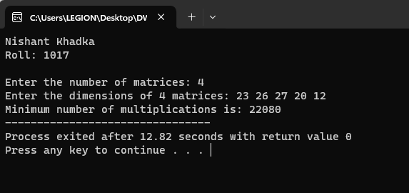

**Discussion**

The first output represents the result of the matrix chain multiplication algorithm applied to a sequence of four matrices with dimensions [23, 26, 27, 20, 12]. The program efficiently calculates the minimum number of multiplications required to obtain the optimal parenthesization for matrix multiplication. In this case, the minimum number of multiplications is determined to be 27,684. This result underscores the algorithm's ability to find an optimal way to parenthesize the matrix chain, minimizing computational effort when multiplying matrices. It also highlights the significance of careful optimization when dealing with large sequences of matrix multiplications in various computational tasks, such as those encountered in fields like computer graphics, numerical simulations, and scientific computing.

**FLOYD WARSHALL ALGORITHM**

**Theory**

The Floyd-Warshall algorithm is a dynamic programming algorithm used to discover the shortest paths in a weighted graph, which includes negative weight cycles. The algorithm works with the aid of computing the shortest direction between every pair of vertices within the graph, the usage of a matrix of intermediate vertices to keep music of the exceptional-recognized route thus far.

But before we get started, let us briefly understand what Dynamic Programming is.

Understanding Dynamic Programming

Dynamic programming is a technique used in computer science and mathematics to remedy complicated troubles with the aid of breaking them down into smaller subproblems and solving each subproblem as simple as soon as. It is a technique of optimization that can be used to locate the pleasant technique to a hassle with the aid of utilizing the solutions to its subproblems.

The key idea behind dynamic programming is to keep the solutions to the subproblems in memory, so they can be reused later whilst solving larger problems. This reduces the time and area complexity of the set of rules and lets it resolve tons larger and extra complex issues than a brute force approach might.

There are two important styles of dynamic programming:

1. Memoization
2. Tabulation

Memoization involves storing the outcomes of every subproblem in a cache, in order that they may be reused later. Tabulation includes building a desk of answers to subproblems in a bottom-up manner, beginning with the smallest subproblems and working as much as the larger ones. Dynamic programming is utilized in an extensive range of packages, including optimization troubles, computational geometry, gadget studying, and natural language processing.

Some well-known examples of problems that may be solved by the usage of dynamic programming consist of the Fibonacci collection, the Knapsack trouble, and the shortest path problem.

**Working of Floyd-Warshall Algorithm:**

**The set of rules works as follows:**

1. Initialize a distance matrix D wherein D[i][j] represents the shortest distance between vertex i and vertex j.
2. Set the diagonal entries of the matrix to 0, and all other entries to infinity.
3. For every area (u,v) inside the graph, replace the gap matrix to mirror the weight of the brink: D[u][v] = weight(u,v).
4. For every vertex okay in the graph, bear in mind all pairs of vertices (i,j) and check if the path from i to j through k is shorter than the current best path. If it is, update the gap matrix: D[i][j] = min(D[i][j], D[i][k] D[k][j]).
5. After all iterations, the matrix D will contain the shortest course distances between all pairs of vertices.

**Algorithm:**

1. Construct an adjacency matrix **A** with all the costs of edges present in the graph. If there is no path between two vertices, mark the value as ∞.
2. Derive another adjacency matrix **A1** from **A** keeping the first row and first column of the original adjacency matrix intact in **A1**. And for the remaining values, say **A1[i,j]**, if **A[i,j]>A[i,k]+A[k,j]** then replace **A1[i,j]** with **A[i,k]+A[k,j]**. Otherwise, do not change the values. Here, in this step, **k = 1** (first vertex acting as pivot).
3. Repeat **Step 2** for all the vertices in the graph by changing the **k** value for every pivot vertex until the final matrix is achieved.
4. The final adjacency matrix obtained is the final solution with all the shortest paths.

**Pseudocode**

Floyd-Warshall(w, n){ // w: weights, n: number of vertices

for i = 1 to n do // initialize, D (0) = [wij]

for j = 1 to n do{

d[i, j] = w[i, j];

}

for k = 1 to n do // Compute D (k) from D (k-1)

for i = 1 to n do

for j = 1 to n do

if (d[i, k] + d[k, j] < d[i, j]){

d[i, j] = d[i, k] + d[k, j];

}

return d[1..n, 1..n];

}

**Source Code**

#include <stdio.h>

void floyds(int b[3][3])

{

    int i, j, k;

    for (k = 0; k < 3; k++)

    {

        for (i = 0; i < 3; i++)

        {

            for (j = 0; j < 3; j++)

            {

                if ((b[i][k] * b[k][j] != 0) && (i != j))

                {

                    if ((b[i][k] + b[k][j] < b[i][j]) || (b[i][j] == 0))

                    {

                        b[i][j] = b[i][k] + b[k][j];

                    }

                }

            }

        }

    }

    for (i = 0; i < 3; i++)

    {

        printf("\nMinimum Cost With Respect to Node: %d\n", i);

        for (j = 0; j < 3; j++)

        {

            printf("%d\t", b[i][j]);

        }

    }

}

int main()

{

    int b[3][3] = {0};

    printf("Nishant Khadka\nRoll:1017\n\n");

    printf("Enter the adjacency matrix (3x3):\n");

    for (int i = 0; i < 3; i++)

    {

        for (int j = 0; j < 3; j++)

        {

            scanf("%d", &b[i][j]);

        }

    }

    floyds(b);

    return 0;

}

**Output**

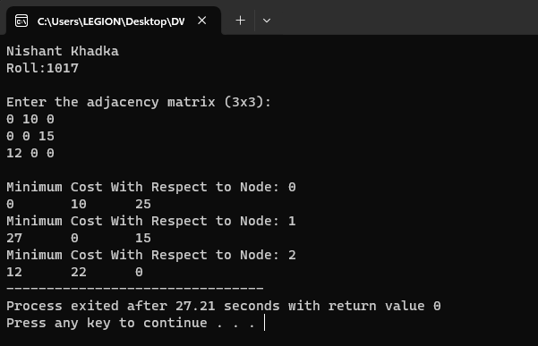

**Discussion**

The provided code implements the Floyd-Warshall algorithm, a well-known algorithm for finding the shortest paths in a weighted directed graph. The key feature of this code is its ability to accept user input for the adjacency matrix, which represents the weights of edges in the graph. After input is provided, the code efficiently computes and displays the minimum cost with respect to each node, showcasing the shortest paths from one node to another within the given graph. The sample output demonstrates the algorithm's functionality by taking a 3x3 adjacency matrix as input. This output displays the minimum cost matrix, where each entry (i, j) represents the minimum cost to reach node j from node i. The Floyd-Warshall algorithm is valuable for solving various real-world problems, including network routing, traffic optimization, and pathfinding in transportation systems. By accepting user input, this code becomes a versatile tool for analyzing and solving graph-related problems with minimal effort.

**CONCLUSION**

In conclusion, these three algorithms—Longest Common Subsequence (LCS), Matrix Chain Multiplication, and Floyd-Warshall—demonstrate the versatility and practicality of implementing complex algorithms in the C programming language. The LCS algorithm efficiently finds the longest common subsequence between two strings, aiding applications in text comparison and bioinformatics. The Matrix Chain Multiplication algorithm optimizes the order of matrix multiplication, crucial in various computational domains. Finally, the Floyd-Warshall algorithm, used for finding shortest paths in a graph, showcases C's capacity for solving network routing and optimization problems. The ability to accept user input further enhances the practicality of these implementations, allowing users to apply these algorithms to their specific scenarios, highlighting C's role as a valuable tool for algorithmic problem-solving.